

# Leicestershire Trading Standards News

## Summer 2023 Newsletter

**The latest news of our work and advice on scams and consumer issues.**

Remember to stay up to date with our latest news by [following us on Facebook](https://www.facebook.com/leicstradingstandards).

Contact Citizen’s Advice Consumer helpline on 0808 223 1133 or [Citizen's Advice online](https://www.citizensadvice.org.uk/) to report, or need advice on all Trading Standards matters.

## Trading Standards in the news

## Shop found to be selling counterfeit cigarettes closed for three months

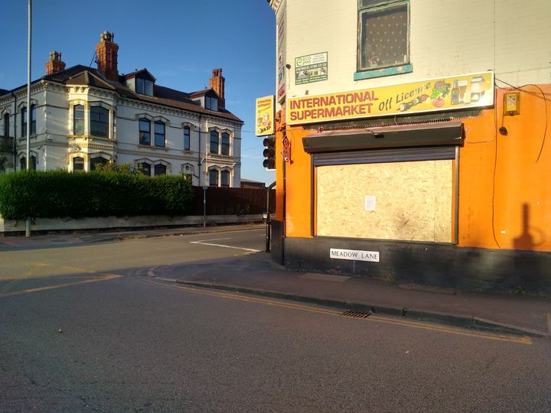Leicestershire Trading Standards officers have worked with our colleagues at [Charnwood Police](https://www.facebook.com/charnwoodpolice?__cft__%5b0%5d=AZVpTleJMKsy2JQO3f1udCO7eZThv6QtMFtI54Ce5HQGtjZtt6ttDE3VjOUftRNqHqBa0dXqPbBdX2Vgr4h5rh7vAyE1GRu2p4HPQ5h0mMTRHkir-PAokotU_wa0oqrnRLYFzZxq_qWPnJ5B6GQVDxrw&__tn__=-%5dK-R), who obtained a Closure Order for International Supermarket, in Meadow Lane, Loughborough, which was granted at Leicester Magistrates’ Court on Thursday 17th August. The Closure Order is for 3 months.

The Closure Order application included the history of illegal tobacco being sold from the premises.

Find out more at [here](https://www.leics.police.uk/news/leicestershire/news/2023/august/shop-found-to-be-selling-counterfeit-cigarettes-closed-for-three-months/).

Cheap, illegal tobacco brings criminality into our communities, increases the risk of selling to children, is an obstacle for those wanting to stop smoking and it creates an unfair trading environment for our law-abiding businesses.

You can report the sale of illegal tobacco on our [website](https://www.leicestershire.gov.uk/business-and-consumers/trading-standards/report-a-trading-standards-issue/online-reporting-form) or via Citizens Advice Consumer Service at 0808 223 1133.

## Stopping unsafe products at East Midlands Airport

Our officers operating at East Midlands Airport have stopped and seized almost 440,000 potentially dangerous or non-compliant items in the last year preventing them making their way into consumers’ homes via shops and online marketplaces. These goods are worth more than £15.3m.

The team have seen a number of toy guns being imported by a number of businesses over the last year.

This gun fires pellets that are to be first immersed in water.

Toy Safety Regulations require that such items should only swell by 50%. This is because the product could swell dangerously causing a choking hazard if swallowed by a child. A product from an incoming consignment was tested and the toy gun pellets were found to swell by 382%. The toy is unsafe and will not be released for sale to consumers.

Our advice is always to be wary when buying goods in online marketplaces and if your child has a toy pellet gun, our advice would be to remove the pellets before use.

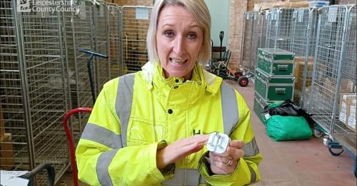

Watch a video of Nicola, one of the East Midlands Airport team, talking about product safety checks made on consignments coming into the [UK](https://www.youtube.com/watch?v=YXYQeFizvow).

**Convenience store ordered to pay thousands after prosecuted for selling fake wine.**

A Leicestershire convenience store has been prosecuted for selling fake wine following an investigation by Leicestershire Trading Standards. Trading Standards officers found 21 bottles of counterfeit Yellow Tail Australian wine for sale during an inspection of the store.

A limited company, which formerly operated the convenience store, was fined £2,500 and ordered to pay costs of more than £2,600. The company’s director was also given a conditional discharge and ordered to pay costs of more than £2,600. Read the Leicester Mercury article [here](https://www.leicestermercury.co.uk/news/leicester-news/convenience-store-ordered-pay-thousands-8655100?fbclid=IwAR2Ej4No2IjQs_8LMJssnhbFElmrOVAx6DEjGKt8EOrypSj0AUGeuZrh_DY).

## Scams in the news

## Facebook hacking scam

## We were contacted in June by a Leicestershire resident who sadly had their social media account hacked. They were contacted by a ‘friend’ on the platform, who unbeknownst to them also had their account hacked. The ‘friend’ asked for personal information, including address and date of birth, before requesting bank details for a “lottery win fund transfer”. At this point, the resident became suspicious and ended the contact.

## A person using a computer and a phone Description automatically generatedHow can you stay safe whilst using social media?

## • Pick a username that doesn’t give away personal information such as your full name and keep your profile private.

## • Be wary of publishing any identifying information about yourself, including phone numbers or pictures of your home or workplace.

## • Don’t use messaging hosted by the platform to send personal information and pictures because if the account is hacked this may become accessible to the hacker.

Great tips on safe social media use can be found at [Get Safe Online](https://www.getsafeonline.org/personal/articles/social-networking-sites/).

**“Hey Mum!” scam texts warning**

The [Chartered Institute of Trading Standards](https://www.tradingstandards.uk/) have warned parents and youngsters alike to be on guard against a new spate of text messaging scams.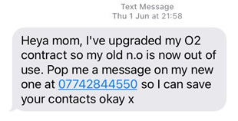

In the scams, a text message purporting to be from the recipient’s son or daughter claims that the sender has a new number or has broken or lost their phone. The sole purpose if to extract personal details and probably the transferring of money.

Take a minute and contact the person they are purporting to be on their original number.

Get further advice from [CTSI](https://shorturl.at/iFGS7).

**Stop
Hang up
Call 159STOP. HANG UP. CALL 159**

Are you aware of "call 159"? If you think someone is trying to trick you into handing over money or personal details - stop, hang up and call 159 to speak directly to your bank.

159 works in the same way as 101 for the police or 111 for the NHS. Use this number get through to your bank safely and securely.

Find out more at [Stop Scams UK](https://stopscamsuk.org.uk/159).

## Moving house in the rented sector? Avoid paying banned letting fees!

With students starting university and a strain for many looking for rented accommodation, Trading Standards are reminding consumers that most tenancy related fees are banned.

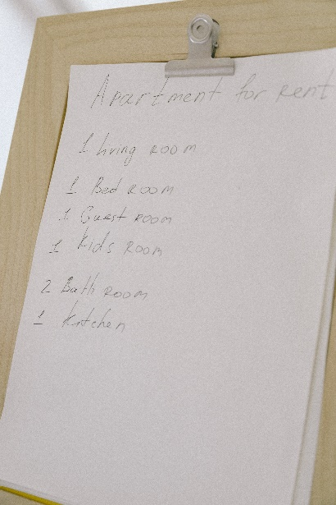If your tenancy started on or after 1 June 2019 landlords and rental agents cannot charge for things like:

• References or other admin

• Credit and immigration checks

• Renewing your tenancy when the fixed term contract ends.

Find out more including what types of tenancy are covered from housing charity [Shelter](https://england.shelter.org.uk/housing_advice/private_renting/letting_agent_fees_for_tenants).

## Booking summer safe fun for the kids

A group of kids playing in a bounce house

Thinking about getting a bouncy castle or other hired equipment for your garden?

Make sure you ask the supplier for a copy of the most recent safety assessment, risk assessment and Portable Appliance Testing documents before you agree to the contract.

The bouncy castle should be adequately anchored with at least 6 anchor points. Electrical safety including the condition of the blower and it’s cabling, and suitability of any extension leads should also be checked.

The supplier should provide clear instructions about safely using the equipment. Find a helpful checklist on safe set up from Bouncesafe.org [here](https://shorturl.at/aiwz4).

Are you concerned about the safety of equipment you have hired for personal use? Contact us via Citizen’s Advice on 0808 223 1133 or at [www.citizensadvice.org.uk](http://www.citizensadvice.org.uk).

## New rules for Financial Services

## Piggy bank with coinsNew rules known as the Consumer Duty came into force on 31st July 2022.

## These new rules set a higher standard of consumer protection in financial services. Firms should provide helpful and accessible support, timely and clear information you can understand. Financial providers must offer products and services that are right for you and provide fair value.

Find out more from the [Financial Conduct Authority](https://www.fca.org.uk/news/news-stories/consumer-duty-higher-standards-financial-services).

## Don’t accept poor quality building work!

Trading Standards East Midlands conducted a project into consumer behaviour and decision-making process in the home improvements sector. Results found that only 32% of consumers reported undertaking any checks relating to the trader they were engaging, and only 43% of consumers obtained 3 or more quotes.

To help you make the most informed decision, consider the following actions:

• Check recommendations and reviews

• Acquire at least 3 quotes

• Obtain full details of the companies providing quotes, the work and price in writing.

If you have an issue with home improvement work and need advice, [Citizens Advice](https://www.citizensadvice.org.uk/consumer/getting-home-improvements-done/problem-with-home-improvements/?fbclid=IwAR1BzBsq1OE2iVLq4rbhSanEXccH6POJpR8UsEouxi-EwqAsvcFszIvSC8k) have great information on what to do.

## Using a reputable airport parking service

A parking lot full of cars

We have received reports relating to meet and greet car parking at airports including additional charges on collection, damage to vehicles and significant additional mileage.

You can find more information on checks to conduct before booking a service and find car parks approved by Park Mark by searching the airport postcode at: [British Parking Association](https://l.facebook.com/l.php?u=http%3A%2F%2Fwww.parkmark.co.uk%2F%3Ffbclid%3DIwAR0tJBVHlXPbYAekOK6eoSR958F1DMjh40CM1C8YBPSwK8TA-u7ShNj1hwc&h=AT1D-6t5NDs99vcQeTwGN7tdjcCiBHqWRkL-UmRjguelFAHztJtnuH40LJpod-bkFMKyR0dLtEJaDvHdzzw6HSP3gSGMQz9CNbjJi03yaE2dVXkts_52GsHeXs3iQr1h7gH7&__tn__=-UK-R&c%5b0%5d=AT1iQvJaHz_qjjtjNwWB-n-QM-eVuvV1D0j93hxHprlkhjAjiO_C8H-FHeCB1vElp-pyXkCLMqXFSMgm2FVvvo6d2cmXC6uA_-dzUcd8-599d5K6Q9_p0tlCX8bVZ5we_Drp3mh3xc-OuBRxZ3ww7wPYURmgceB-DIKdFRyab5MhCb6I9E7-vOeJjKK4eiW-dNclwwVPnPit" \t "_blank).



**Leicestershire Trading Standards Service**

Tel: 0116 305 8000

Email: [tradingstandards@leics.gov.uk](mailto:tradingstandards@leics.gov.uk)

[/LeicsTradingStandards](https://www.facebook.com/LeicsTradingStandards)

