

# Winter 2023/24

**The latest news of our work and advice on scams and consumer issues.**

Remember to stay up to date with our latest news by [following us on Facebook](https://www.facebook.com/leicstradingstandards).

Contact Citizen’s Advice Consumer helpline on 0808 223 1133 or [Citizen's Advice online](https://www.citizensadvice.org.uk/) to report an issue or get advice on all Trading Standards matters.

## Fraudster who went on the run sentenced to four years in prison.

A businessman from Leicester has been found guilty of selling fraudulent franchise licences to victims across the UK. Nazir Abdul Rashid Daud, who went on the run before his trial, has been sentenced to four years in prison and banned from being a company director for 15 years.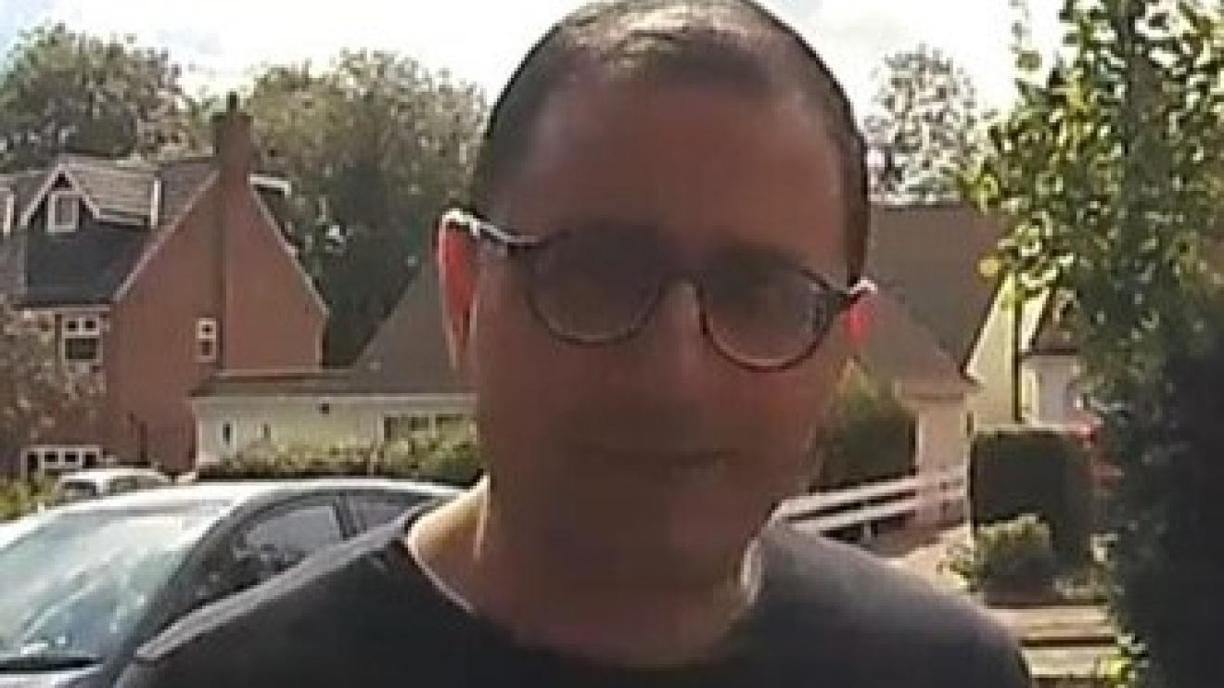 Mr Daud was ordered to pay prosecution costs of £30,046. His company, Payrolls Direct Ltd, was fined £973,000.

The prosecution was brought following an investigation by Leicestershire County Council Trading Standards Service, which received statements from 18 victims.

Payrolls Direct Ltd had advertised franchise licences for a new cloud-based payrolls system, for sale between £5,995 and £9,995.

Franchisees would sign up clients, process payroll for each employee of the company they signed up, and Payrolls Direct would take 20 per cent of the fee, with the franchisee keeping the rest.

Mr Daud claimed that buying a franchise licence would allow people to earn between £250 and £2,000 per month, depending on how much time they put into the business and how many clients they signed up. Advertising for Payrolls Direct also promised franchisees initial training, ongoing unlimited support, marketing materials and networking opportunities with successful franchisees.

But only one was able to sign up any clients, and as the promised unlimited help, support and training was never provided, the franchisees were unable to use the payrolls system, leading to a contract with clients being terminated.

The cash value of the fraud was put at more than £320,000

Mr Daud’s co-defendant Anthony Raybould was sentenced to 22 months imprisonment, suspended for two years.

## Could you spot an illicit vape?

It is illegal to sell vapes containing nicotine to anyone under the age of 18. Our Trading Standards team responds to reports we receive of vapes being sold in the county to anyone underage. We meet with businesses and advise them of their responsibilities to check customer ID and record checks made.

We also investigate reports of illicit vapes being sold. Illicit vapes are products which are not legal in the UK.

A few of the ways to spot an illicit vape:

* Check that the products come with a 2ml tank, which gives the number of puffs between 600-650.
* Check the warning label - if it doesn’t cover 30% of the front and back of the pack, it’s not allowed to be on the UK market.
* Check the nicotine content – the maximum nicotine content allowed for vapes is 20mg/ml.
* Check if a vape is on the registered [Medical Health Regulatory Authority list](https://cms.mhra.gov.uk/ecig).

If you know of anyone selling illicit vapes, or selling vapes to someone underage in the county, please report this to [Leicestershire Trading Standards](https://www.leicestershire.gov.uk/business-and-consumers/trading-standards/report-a-trading-standards-issue/online-reporting-form?fbclid=IwAR0GrpYdN4DWtVLiJJWVt-aECizPmCULtsZAytbvhxs9kzUC_mDMgjLwEtI).

## Shopkeeper sold counterfeit cigarettes to Trading Standards Officers on three separate occasions.

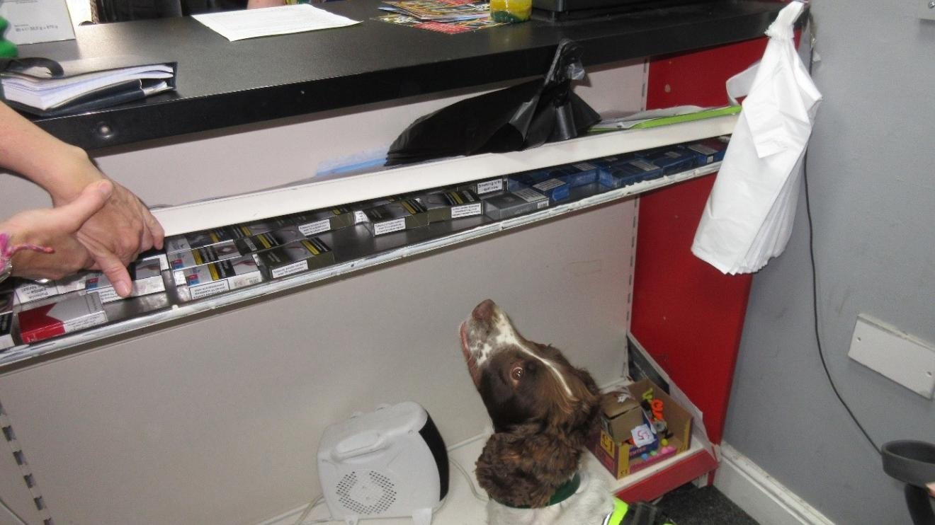The owner of a Coalville convenience store has been ordered to carry out 150 hours of unpaid work after he pleaded guilty to selling illicit tobacco from under the counter in his shop.

Leicestershire Trading Standards service prosecuted the individual after officers carried out three test purchases on separate occasions.

In June 2022, a Trading Standards test purchaser was able to buy a counterfeit packet of cigarettes for £5 – less than half the price of a genuine pack - and offered various other brands.

A further packet of cigarettes was sold by the business in July 2022, followed up by an enforcement visit to search for illegal tobacco. The search was supported by the police and a tobacco detection dog named Billy, which successfully identified a concealed shelf under the counter containing 107 packets of cigarettes. The seized tobacco had a street value of £535 and would have been worth an estimated £1,123.50 if the cigarettes had been genuine brands.

This enforcement action did not deter the business owner who again sold a further two packets of illegal cigarettes in October 2022 when Trading Standards again made a test purchase.

Magistrates imposed a Community Punishment Order which means 150 hours of unpaid work within the next 12 months for the individual, who was also ordered to pay prosecution costs of £1,000 and a victim surcharge of £95.

Trade in illicit tobacco costs the country more than £2 billion in lost tax revenue each year. It funds other criminality, undermines public health and often provides a cheap source of tobacco for young people.

You can report concerns about the sale of illegal tobacco using our [online reporting form](https://www.leicestershire.gov.uk/business-and-consumers/trading-standards/report-a-trading-standards-issue/online-reporting-form) or by calling 080 223 1133.

## Beware HSBC scam texts!

This scam text purports to be from HSBC about a pending payment but is a “smishing” attempt by a scammer. Smishing is a phishing cybersecurity attack carried out over mobile text messaging, also known as SMS phishing, and the goal is to get you to reply with your personal or financial information.

Scammers often send fake text messages that look like they’ve come from your bank, or another trusted organisation. A text like this may:

• Encourage you to take urgent action

• Ask you to verify new payees, transactions or devices

• Appear to confirm a payment

• Look like real messages. They may show up in the same thread as genuine messages you’ve received from an organisation.

If you are concerned about a message from your bank, contact them directly using contact details from a trusted source.

Get more information on how to bank safely online at [Get Safe Online](https://www.getsafeonline.org/personal/articles/banking/).

Find out how to recognise genuine texts from [HSBC](https://www.hsbc.co.uk/help/security-centre/received-a-text/).

## Phishing fraudsters target Facebook users

Fraudsters are sending messages on Facebook telling you that 'Your Facebook page will be permanently deleted'. The messages go on to state this is due to either not complying with ‘terms of use’ or 'a post that infringes our trademark rights', and it contains a link to verify your account. The link leads to a phishing website to obtain your personal and/or financial information

Don't click suspicious links: if you get a suspicious email, text or social media message claiming to be from Facebook, don't click any links or attachments.

* Check in your Facebook settings to see whether it came from Facebook.
* Strengthen your online security by enabling two-factor authentication which adds an extra security layer to your accounts across the Internet.

Get more information on avoiding [Facebook](https://www.facebook.com/help/1674717642789671/?helpref=related_articles) scams.

Check out great advice from the [National Cyber Security Centre](https://www.ncsc.gov.uk/section/information-for/individuals-families#section_2).

## Dangerous baby products found online

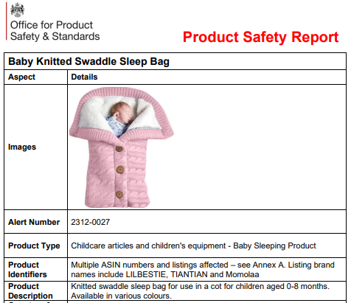Leicestershire Trading Standards have regularly warned our residents to be wary of the safety of some products bought online. Some items bought via popular online marketplaces may not have been adequately tested to UK safety standards and could therefore pose a safety risk during use.

At the end of 2023 we publicised this safety recall of a knitted swaddle sleep bag sold via Amazon. It has now been removed from sale because of the serious risks it poses to babies, including suffocation, overheating and death.

The dangers of the product were highlighted by a joint report from the [Child Accident Prevention Trust](https://capt.org.uk/dangerous-baby-products-in-uk-homes/?utm_source=capt&utm_medium=email&utm_campaign=babyproducts&mc_cid=ebf8aa3f67&mc_eid=741790ebff&fbclid=IwAR3Qqo3HV-V8gw14rxMrwqnSgFVJ2LitftKZLACVXu_j8yuvkyBQXFpWGhQ) and [ITV](https://www.itv.com/news/2023-12-13/tragedies-waiting-to-happen-baby-products-sold-online-putting-infants-at-risk) which warned many parents may not be aware of the dangers products they have bought online could pose to a small child.

Online marketplaces offer a huge range of products, often of good quality and at competitive prices, but in some cases the way they work can lead to customers buying unsafe or counterfeit goods.

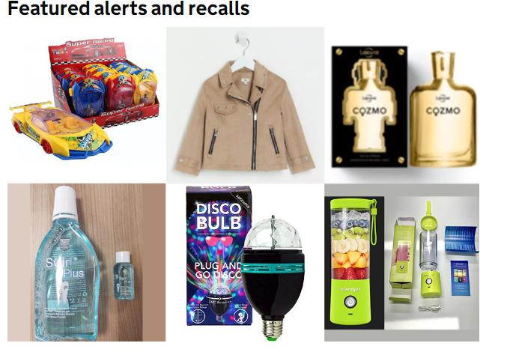If you buy goods in a shop the chances are that they’ve been manufactured or imported by a business based in the UK, and the business will have systems in place to check they’re OK; if they aren’t, they may face legal action. The same is often true of online sellers, but not always. Sellers using online marketplaces can be located anywhere in the world and use a UK distribution centre to post out their goods. They are out of reach of UK Courts, so there’s little incentive to get things right.

When you look at a listing and it says the goods are in the UK, that doesn’t mean that the seller is too! If possible, look for the trader’s details and address. If the trader isn’t in the UK, be aware that the goods might never have been tested.

We endeavour to put out product safety recalls on our [Facebook](https://www.facebook.com/leicstradingstandards) page as we receive them but due to the volume there are times that we can’t publish them all. You can sign up to alerts from [Office for Product Safety and Standards](https://www.gov.uk/government/organisations/office-for-product-safety-and-standards) to receive all their product safety warnings. Visit their page for the most recent list of [UK recalls](https://www.gov.uk/product-safety-alerts-reports-recalls.).

## Warning over banned imported American candy flooding the UK

[The Chartered Trading Standards Institute](https://www.tradingstandards.uk/) has issued a serious warning to parents around unauthorised ingredients contained in imported American sweets and fizzy drinks with known links to hyperactivity and cancer in children that are readily accessible across UK highstreets including Leicestershire.

**Colourful candy

**American Candy has grown in popularity over the last few years due to its promotion on social media channels. Some imported products like American confectionery weren't designed to be sold here, and they might contain additives that aren’t authorised to be sold in the UK.

Consumers that buy them could be at risk from a lack of allergy labelling, or the inclusion of ingredients that don’t meet our high UK food safety standards.

Find out more at [tradingstandards.uk](https://www.tradingstandards.uk/news-policy-campaigns/news-room/2023/banned-imported-american-candy-with-huge-child-appeal-and-worrying-side-effects-floods-the-uk/).

## Rogue traders take advantage of a crisis

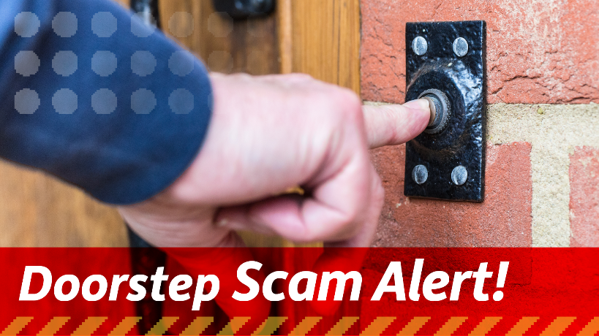February’s gas outage for residents in the Ratby and Kirby Muxloe areas and recent storms causing floods across the county mean householders should be increasingly vigilant of rogue traders who seek to take advantage of the situation.

Following such local incidents Trading Standards often receive reports of rogue traders offering to repair or provide a new gas boiler, or other home repairs without being able to provide ID to confirm who they are.

Legitimate callers will always be happy to show their identification card - please don’t hesitate to ask to see it. If in doubt, call the organisation to check the caller is who they say they are.

Don’t fall for the urgency that traders will often imply! We advise:

• Always get a second and third opinion and never feel pressurised into agreeing to work immediately.

• Do not agree to any work on your doorstep, obtain full details of the company, the work and price in writing and never pay in cash.

• If the trader is legitimate, they won’t mind waiting for you to come back to them once you have made an informed decision. Be wary of those that say they can start straight away, whatever reason they give you.

If you feel in immediate danger, call the police on 999 or to report a non-urgent matter you can contact the police on 101. Visit the [Citizen’s Advice](https://www.citizensadvice.org.uk/consumer/getting-home-improvements-done/before-you-get-building-work-done/) page on what to do before you get work done on you home.

## A counterfeit Dyson hair dryer Unsafe electricals and toys seized at East Midlands Airport

Our team at East Midlands Airport is kept busy checking products coming into the UK for compliance with product safety rules.

The team recently discovered a consignment of what they thought were Dyson hairdryers. On closer examination, although they looked identical to Dyson, they did not have the Dyson name. Dyson confirmed that the shape of the product infringes their trademark.

When our officers screen tested the product, they found it had a lightweight fuse as well as no CE mark, and other labelling issues. Although the product wasn’t formally tested, it is likely to be unsafe.

Find out more about the risks of buying counterfeit products from [Get Safe Online](https://www.getsafeonline.org/personal/articles/counterfeit-goods/?fbclid=IwAR3iTeiQahsuBj4VRB0vC5D4Ce9t2he6YPnVItOX80QVO62PSx5oSs0ZhG0).

In addition to electrical goods, the team also check cosmetics, perfume and toys entering the UK at East Midlands. At the beginning of 2024 our officers opened a consignment of magnetic toys which were heading to a well-known fulfilment centre.

The toys were sent for formal testing as there are well publicised concerns with magnetic toys. The test results show that the magnet strength was 10 times the allowed permitted. The size of the magnets also fitted into the test cylinder which represents a child’s throat and would therefore also be a choking hazard.

Swallowing magnets which may stick together can cause a perforation of the intestine.

Read more on the dangers of small magnets to children with advice from [ROSPA](https://www.rospa.com/policy/home-safety/advice/product/magnet-safety).

## Have you changed your mind about something you purchased online?

A small shopping cart on a computer

If you bought the item online, over the phone or by mail order, you automatically get a 14-day ‘cooling-off period’ when you buy something you haven’t seen in person - unless it’s bespoke or made to measure.

The cooling-off period starts the day after you receive your order, and there doesn’t need to be anything wrong with the item for you to get a refund.

A cooling off period isn’t offered for perishable items like flowers or food, personalised or custom-made items and sealed items such as DVD’s or software. You also don’t get a cooling off period if the items are purchased from a private individual.

Find out more and how to exercise your rights with advice from [Citizens’ Advice](https://www.citizensadvice.org.uk/consumer/changed-your-mind/changing-your-mind-about-something-youve-bought/).



**Leicestershire Trading Standards Service**

Tel: 0116 305 8000

Email: [tradingstandards@leics.gov.uk](mailto:tradingstandards@leics.gov.uk)

[/LeicsTradingStandards](https://facebook.com/LeicsTradingStandards)

